Report :"Gem Hunter”

· **Purpose of the report:**

* This report presents the development plan for a VR game titled **"Gem Hunter"**, where the player collects gems in a 3D interactive environment using VR controllers.
* **Game parts and characters:**
* Single-player game.
* Main character: the hunter.
* Collectible gems and avoidable obstacles

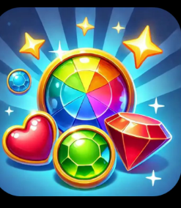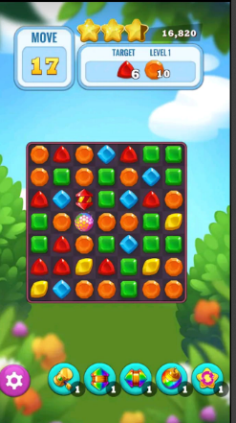

· **Game levels:**

Level 1: Collect 5 gems.

Level 2: Collect 10 gems + avoid obstacles.

Level 3: Higher speed and difficulty.

Win: Collect all gems.

Lose: Time runs out or hit obstacles.

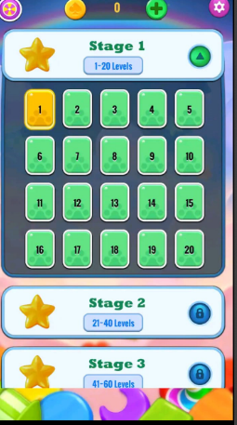

· **Game scenes:**

1-Main Menu

2-Play Scene

3-Win Scene

4-Game Over Scene

5-Options Screen

* **Game controls:**
* Move using VR controller or keyboard arrows.
* Collect gems by approaching them.
* Activate switch by pressing a virtual button.
* **Time plan:**
* Each day is assigned a task (design – code – test – polish – deliver).